TERRAFORM - FINAL – TASK
============================================================================

- Create VPC
- AWS Provider - Terraform will create resources in AWS Stockholm region (eu-north-1).
- resource "aws_vpc" "main"
→ Creates a VPC in AWS (name inside Terraform = main)
- cidr_block = "10.0.0.0/16"
→ Your VPC IP range will be:
10.0.0.0 to 10.0.255.255 (65,536 IPs)
- enable_dns_support = true
→ Enables DNS resolution inside the VPC (needed for AWS services)
- enable_dns_hostnames = true
→ Instances inside VPC can get public DNS names (useful for EC2)
- tags Name = "my-vpc"
→ Tag shows this name in AWS console as my-vpc
- In the VPC Dashboard → Your VPCs
You can see a VPC created:
- Name: my-vpc
- IPv4 CIDR: 10.0.0.0/16
- State: Available
- That means Terraform successfully created your VPC.

- provider "aws" {
- region = "eu-north-1"
- }

- # 1. Create VPC
- resource "aws_vpc" "main" {
- cidr_block = "10.0.0.0/16"
- enable_dns_support = true
- enable_dns_hostnames = true

- tags = {
- Name = "my-vpc"
- }
- }
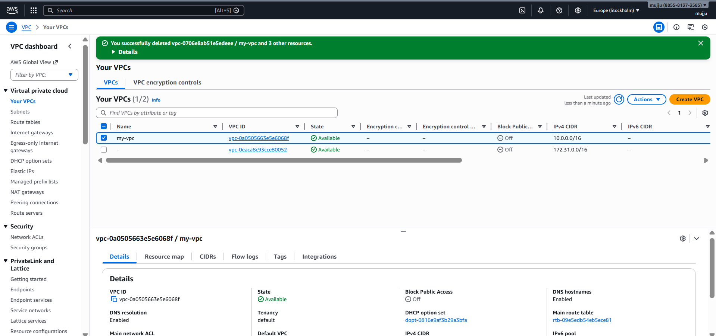

- Create Internet gateway

- resource "aws_internet_gateway" "gw"
→ Creates an Internet Gateway (Terraform name = gw)
- vpc_id = aws_vpc.main.id
→ Attaches the Internet Gateway to your VPC
(Terraform takes VPC ID automatically from aws_vpc.main)
- tags Name = "my-igw"
→ Shows IGW name as my-igw in AWS console
- In VPC Dashboard → Internet Gateways
You can see:
- Internet Gateway Name: my-igw
- State: Attached
- Connected to your VPC (my-vpc)

- # 2. Create Internet Gateway
- resource "aws_internet_gateway" "gw" {
- vpc_id = aws_vpc.main.id

- tags = {
- Name = "my-igw"
- }
- }
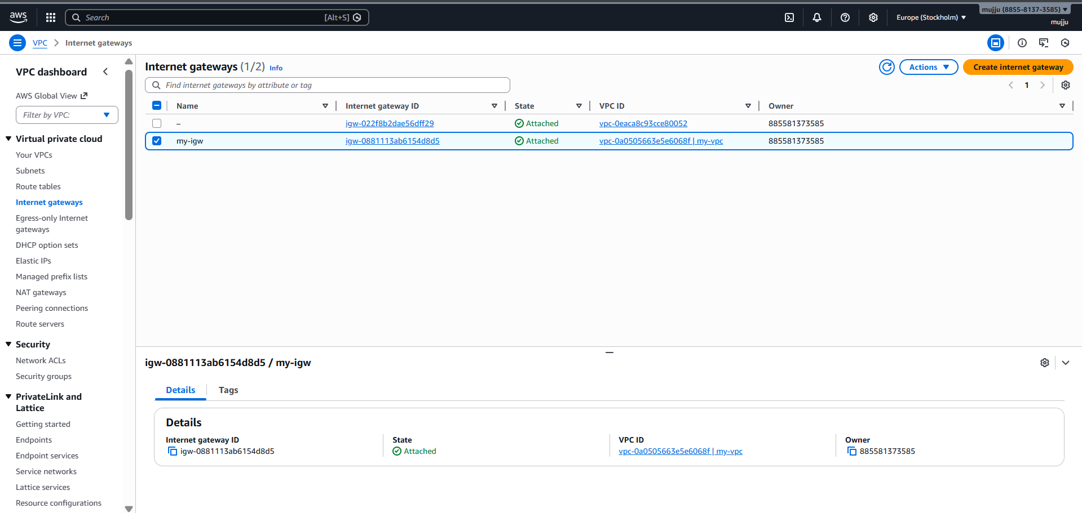

- Create Custom Route Table

- resource "aws_route_table" "public_rt"
- Creates a new Route Table
- Terraform name = public_rt
- vpc_id = aws_vpc.main.id
- This Route Table belongs to your VPC (my-vpc)
- 0.0.0.0/0 = All Internet traffic
- gateway_id = IGW means:
Any traffic going outside the VPC should go through the Internet Gateway
This makes it a PUBLIC route table
- Name shown in AWS = my-public-rt
- In AWS VPC → Route Tables
You can see my-public-rt
And inside Routes tab:
10.0.0.0/16 → local
0.0.0.0/0 → igw-xxxx (Active)

- # 3. Create Custom Route Table
- resource "aws_route_table" "public_rt" {
- vpc_id = aws_vpc.main.id

- route {
- cidr_block = "0.0.0.0/0"
- gateway_id = aws_internet_gateway.gw.id
- }

- tags = {
- Name = "my-public-rt"
- }
- }

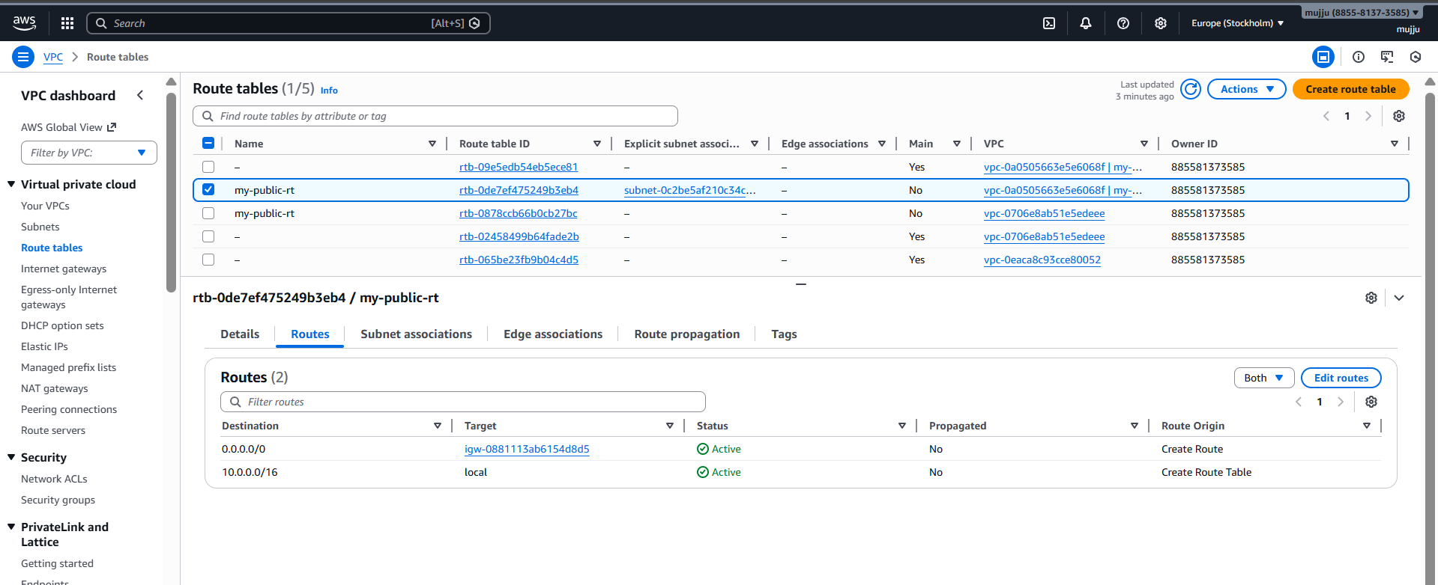

- Create Subnet
- Creates subnet inside your my-vpc
- IP range:
10.0.1.0/24
→ Total usable IPs ≈ 251
- availability_zone = "eu-north-1a"
- Subnet will be created in Stockholm AZ: eu-north-1a
- In AWS → VPC → Subnets
You can see:
Name = my-public-subnet
CIDR = 10.0.1.0/24
Status = Available

- # 4. Create Subnet
- resource "aws_subnet" "public_subnet" {
- vpc_id = aws_vpc.main.id
- cidr_block = "10.0.1.0/24"
- availability_zone = "eu-north-1a"
- map_public_ip_on_launch = false

- tags = {
- Name = "my-public-subnet"
- }
- }
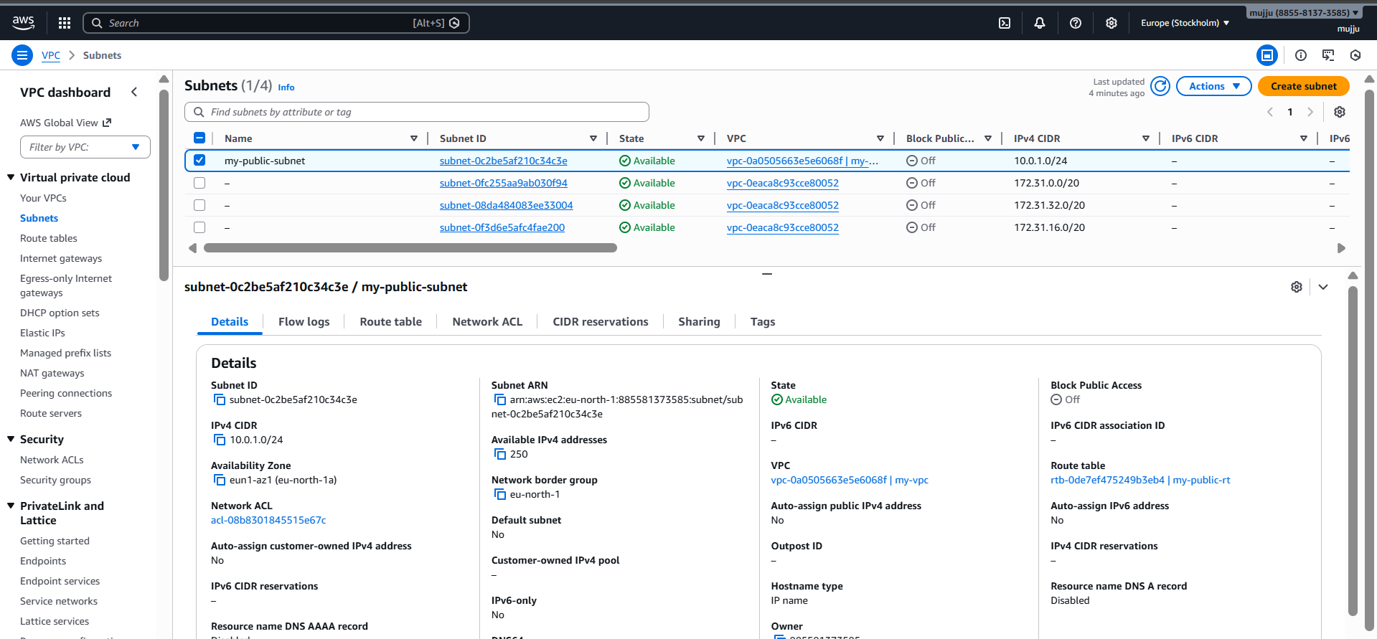

- Associate subnet with Route Table
- Any EC2 inside my-public-subnet
- Will follow rules from my-public-rt
- So it can use the route:
0.0.0.0/0 → Internet Gateway
- In Subnet → Route Table tab
you can see:
Route table = my-public-rt
and routes:
- 10.0.0.0/16 → local
- 0.0.0.0/0 → igw-xxxx
- So your subnet is now connected to internet routing

- # 5. Associate Subnet with Route Table
- resource "aws_route_table_association" "rta" {
- subnet_id = aws_subnet.public_subnet.id
- route_table_id = aws_route_table.public_rt.id
- }
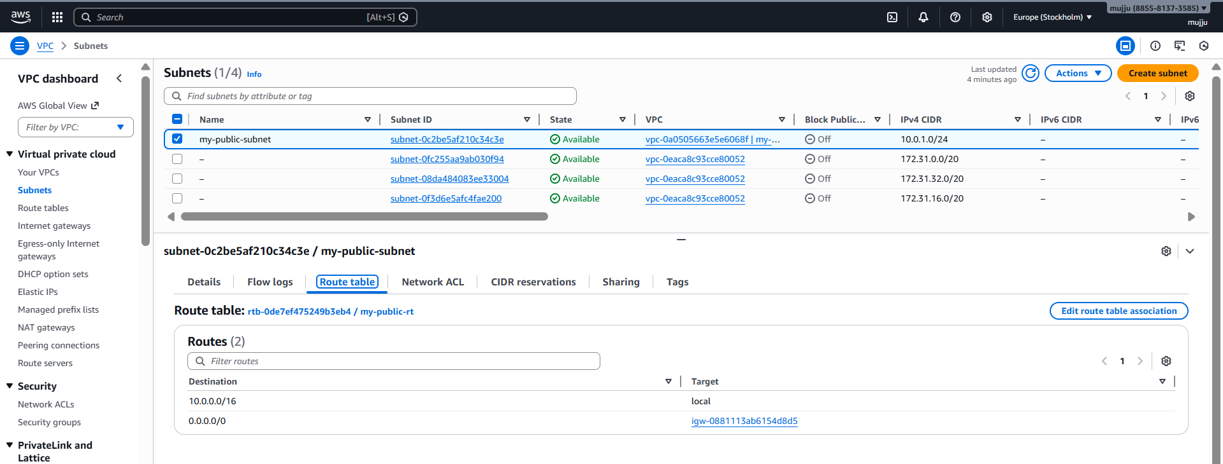

- Create Security Group to allow port 22.80,443
- resource "aws_security_group" "web_sg"
- Creates a Security Group in AWS
- Terraform reference name = web_sg
- SG Name in AWS → my-sg
- Description → tells purpose
- vpc_id → SG is created inside your VPC (my-vpc)
- Allows SSH login
- Port: 22
- Protocol: TCP
- Source: 0.0.0.0/0 (Everyone / Internet)
- Allows website traffic on HTTP
- Accessible from internet
- Allows secure web traffic HTTPS
- Accessible from internet
- Allows all outbound traffic
- Protocol -1 means ALL protocols
- To anywhere 0.0.0.0/0
- This is the default AWS outbound behavior
- Inbound Rules Page
- You can see 3 inbound rules created:
- SSH → TCP 22 → 0.0.0.0/0
- HTTP → TCP 80 → 0.0.0.0/0
- HTTPS → TCP 443 → 0.0.0.0/0
- Outbound Rules Page
- You can see:
- All traffic → All ports → Destination 0.0.0.0/0

- # 6. Create Security Group (22, 80, 443)
- resource "aws_security_group" "web_sg" {
- name = "my-sg"
- description = "Allow SSH, HTTP, HTTPS"
- vpc_id = aws_vpc.main.id

- ingress {
- from_port = 22
- to_port = 22
- protocol = "tcp"
- cidr_blocks = ["0.0.0.0/0"]
- }

- ingress {
- from_port = 80
- to_port = 80
- protocol = "tcp"
- cidr_blocks = ["0.0.0.0/0"]
- }

- ingress {
- from_port = 443
- to_port = 443
- protocol = "tcp"
- cidr_blocks = ["0.0.0.0/0"]
- }

- egress {
- from_port = 0
- to_port = 0
- protocol = "-1"
- cidr_blocks = ["0.0.0.0/0"]
- }

- tags = {
- Name = "my-sg"
- }
- }
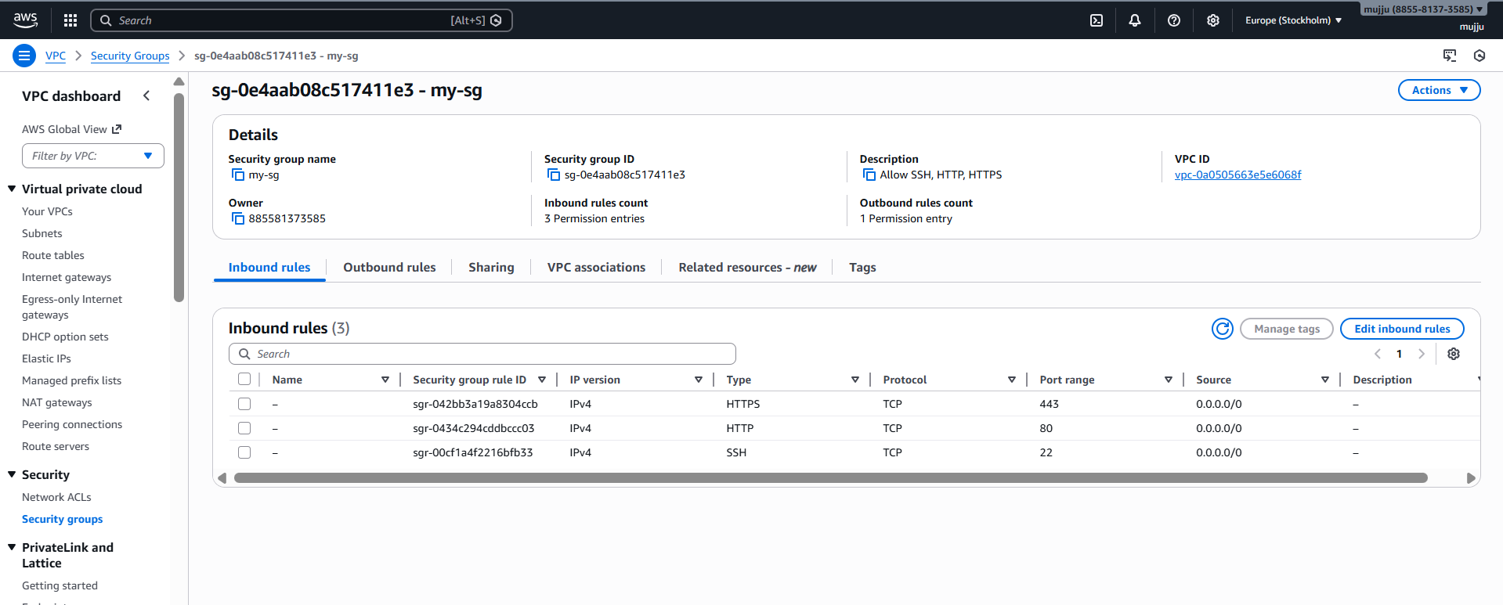

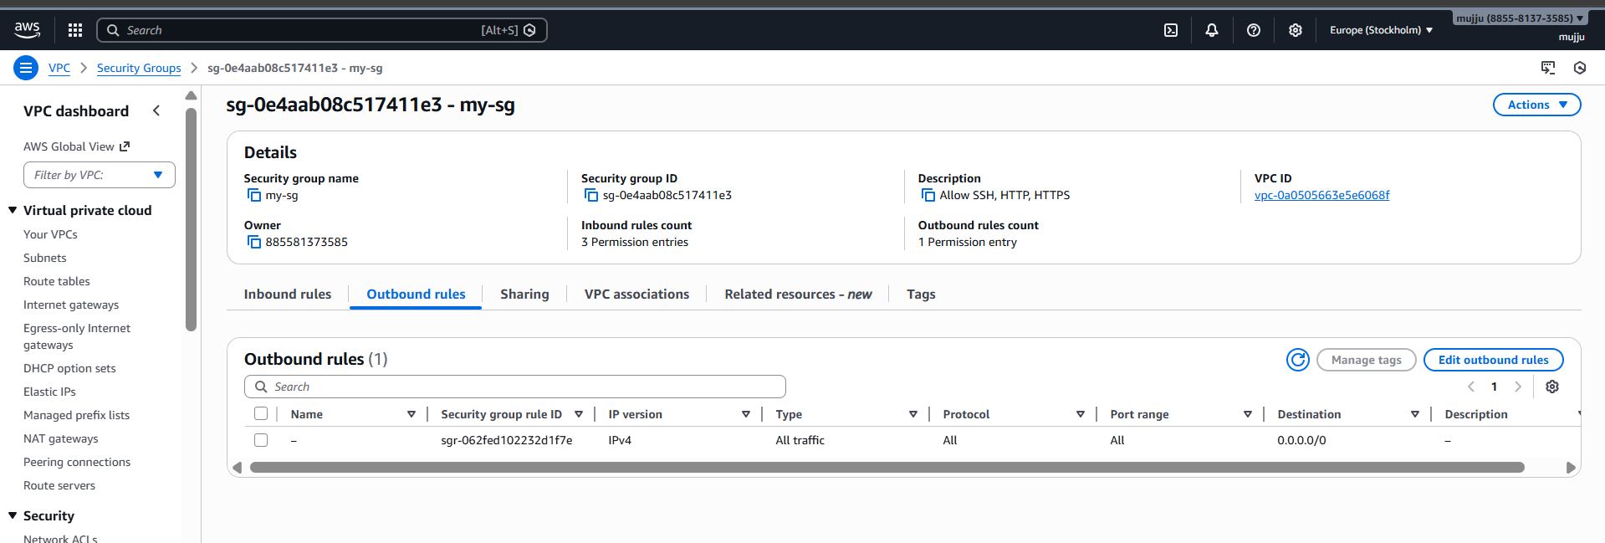

- Create a network interface with an ip in the subnet that was created in step 4

- Creates an Elastic Network Interface (ENI) inside your public subnet

- Gives it a fixed private IP: 10.0.1.50

- Attaches your security group: my-sg (22,80,443 allowed)
- Why ENI is used?

- ENI helps you keep same private IP + same public EIP even if instance changes.

- Output (AWS Console)

- In EC2 → Network Interfaces
- You can see:
- Name: my-eni
- Subnet: my-public-subnet
- Private IP: 10.0.1.50
- Security Group: my-sg
- # 7. Create Network Interface
- resource "aws_network_interface" "my_eni" {
- subnet_id = aws_subnet.public_subnet.id
- private_ips = ["10.0.1.50"]
- security_groups = [aws_security_group.web_sg.id]

- tags = {
- Name = "my-eni"
- }
- }
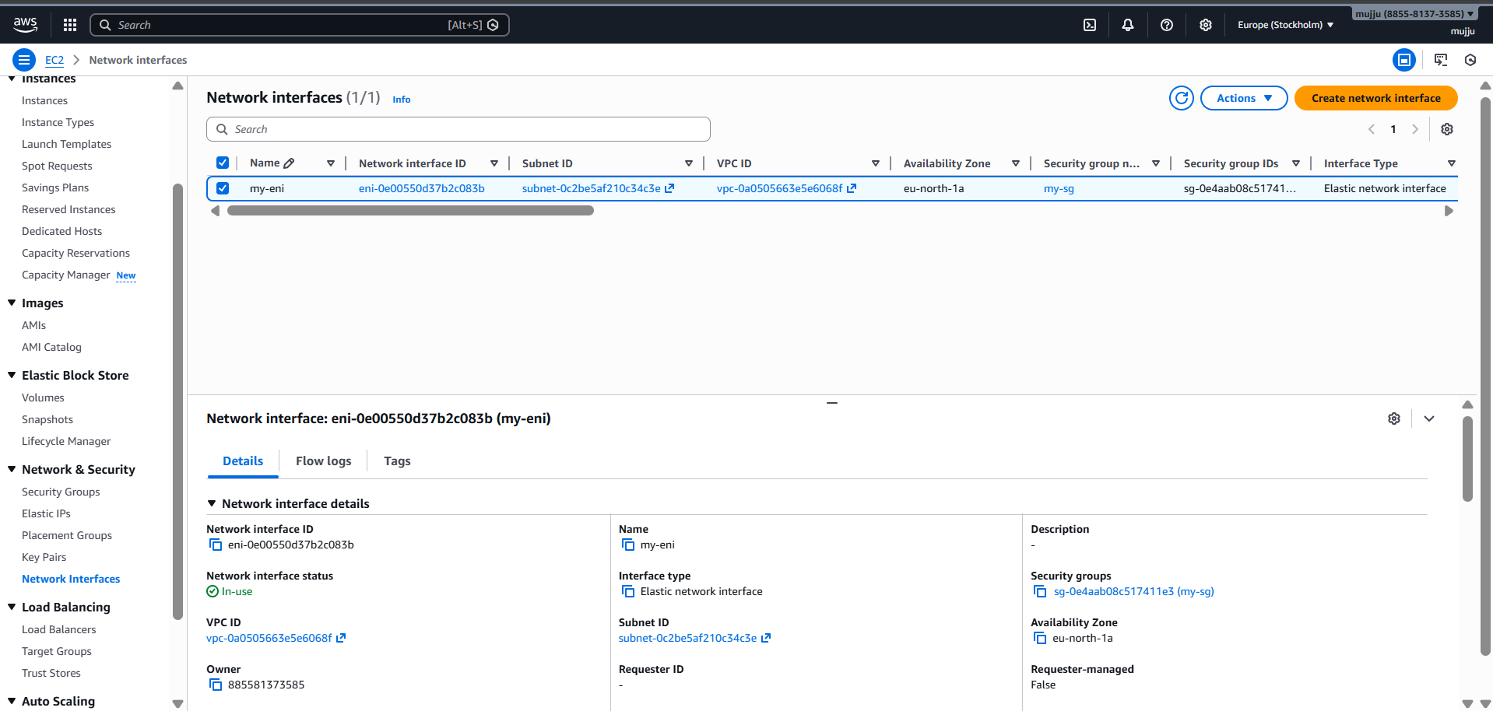

- Assign an elastic IP to the network interface created in step 7
- Creates a static public IP (Elastic IP)
- Attaches it to ENI my-eni
- Maps it with your private IP 10.0.1.50
- Result:
Your server will get a permanent Public IP.

- Output (AWS Console)
- In EC2 Instances
You can see:
Elastic IP assigned (example): 16.170.72.146
Private IP: 10.0.1.50

- # 8. Assign Elastic IP to Network Interface
- resource "aws_eip" "my_eip" {
- domain = "vpc"
- network_interface = aws_network_interface.my_eni.id
- associate_with_private_ip = "10.0.1.50"

- tags = {
- Name = "my-eip"
- }
- }

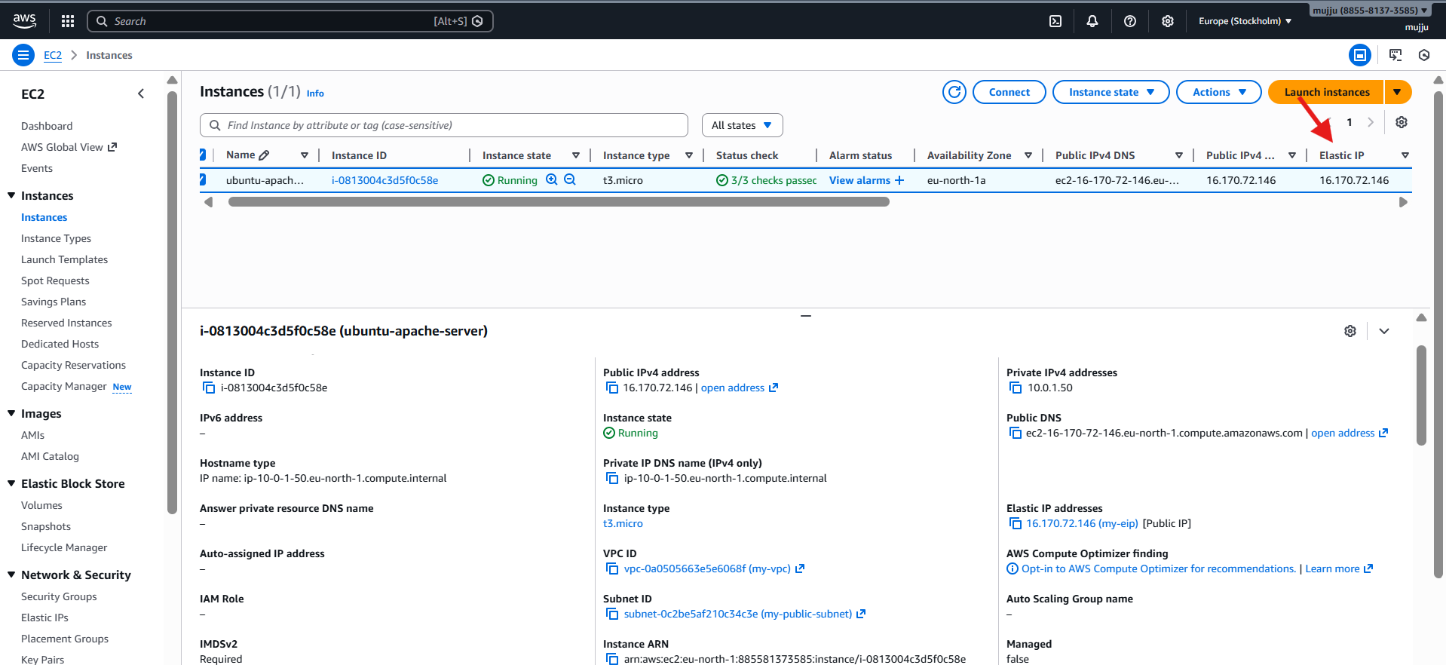

- Create Ubuntu server and install/enable apache2
- Instance will use your ENI my-eni
- So instance gets:
- private IP 10.0.1.50
- Elastic IP public IP
- User Data Script
- This runs automatically when server boots:
- updates packages
- installs apache2
- starts apache
- enables apache on restart

Output (AWS Console)
- In EC2 → Instances
- You can see:
- Instance is running: ubuntu-apache-server
- Public IP = Elastic IP
- Apache running inside instance
- # 9. Create Ubuntu Server and Install Apache
- resource "aws_instance" "web_server" {
- ami = "ami-073130f74f5ffb161" # Ubuntu 22.04 LTS (eu-north-1)
- instance_type = "t3.micro"

- network_interface {
- network_interface_id = aws_network_interface.my_eni.id
- device_index = 0
- }

- user_data = <<-EOF
- #!/bin/bash
- sudo apt update -y
- sudo apt install apache2 -y
- sudo systemctl start apache2
- sudo systemctl enable apache2
- EOF

- tags = {
- Name = "ubuntu-apache-server"
- }
- }

